Hello Parents/Primary Carers,

Bowen Street Community Centre has moved from upfront payments for all childcare fees onto Direct Debit fortnightly payments, as our Centre will have to go cashless to ensure compliance with the Child Care Subsidy.

Childcare payments are made by direct debit fortnightly in advance via Xpay by Debit Success.
If you are receiving Childcare Subsidy this means that you will only pay the gap fee once you have authorized your CWA and linked our centre in your MyGov Account.
Xpay by Xplor is a simple and secure payment system that enables childcare providers and families to comply with the updated digital payment requirements set by the Department of Education.

Follow the steps below to set up Direct Debit to ensure set up of payments before your child commences daycare.

Via Mobile App
Parents/Primary Carers can add or update bank details from the mobile Xplor App.
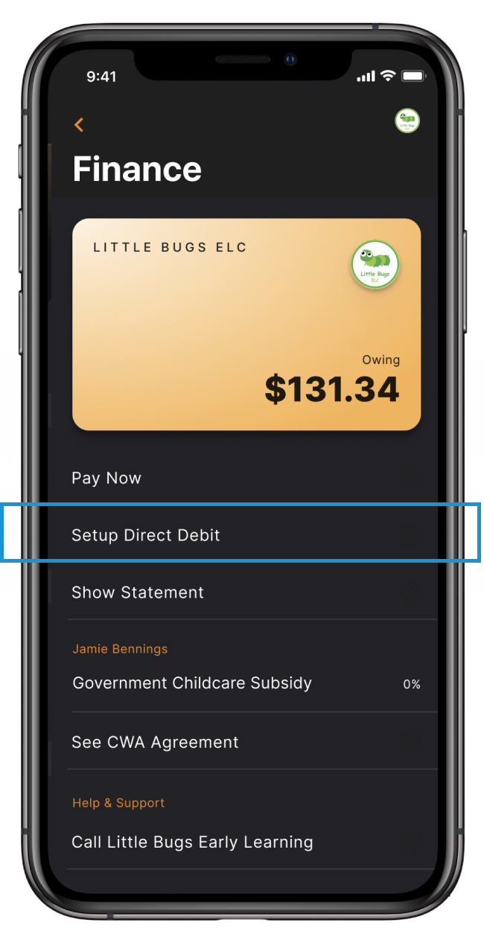
- You will see a menu option titled "Setup Debit Debit" (see above). Tap it to begin the direct debit payment configuration.
- If you have not setup an account with DebitSuccess yet, you'll need to complete some basic information and agree to the billing terms. If you have any concerns about these terms, please reach out to your service.
- On the next screen, you can choose to enter your credit card details or your bank details
- Once you have saved your banking details successfully, your family's billing schedule is fortnightly.
- You can edit your banking details through this tab at any stage
- Please get in touch with the administrator if you have any issues and they will be able to assist or get in contact with support on your behalf.
Please note, if your Parent Account is connected to more than one Centre you can Toggle Between Centres and will need to add your payment information at each individual service.

