CHILDCARE SUBSIDY
The childcare subsidy is a means-tested benefit based on your family’s combined income and fortnightly activities such as work, study or volunteering. You can access more information about the Child Care Subsidy and how to apply for it here:
https://www.dese.gov.au/child-care-package/child-care-subsidy
STEP 1 - HOW TO CLAIM
1. Get ready to claim
The easiest way to claim is online.
To claim online, you need a myGov account linked to Centrelink.
If you don’t have a myGov account or a Centrelink online account you’ll need to set them up.

2. Get your documents ready
You’ll need to get some supporting documents ready to help answer some of the questions in the claim.

3. Make your claim
Sign in to myGov and go to Centrelink.
Select Payment and Claims from the menu, then Claims, then Make a claim.
Under Families, select Get started.

Answer all the questions. Each screen has information to help you complete the claim. This includes how to submit your supporting documents.
Submit your claim.
For help, use our online guide to claim Child Care Subsidy.

4. Track your claim
After you submit your claim online, you’ll get a receipt telling you:
that you’ve successfully submitted your claim
the ID number of your claim
the date we estimate your claim will be complete
a link to track its progress.
You can track the progress of your claim online. Sign in to myGov and go to Centrelink, or use the Express Plus Centrelink mobile app.
If you completed your claim but the enrolment details were missing, you need to take action. Ask your provider to submit these details to us so you can confirm them.
We’ll also let you know the result of your claim. We’ll send an assessment notice to either your:
myGov Inbox
Centrelink online account
Express Plus Centrelink mobile app.
If you don't get electronic letters, we'll send your notice in the mail.

Once you are assessed, the outcome will be available in your Centrelink online account through myGov. Select Child Care Subsidy from the menu, then Child Care Subsidy Summary to view the outcome.

STEP 2
Parent claiming CCS from Centrelink to provide the following to Bowen Street (enrolment form)
Parent –Primary Carer
CRN Number
Parent Date of Birth
Child
CRN Number

STEP 3
Parent and Child CRN details and childcare sessions entered onto Xplor.
A Complying Written Agreement (CWA) is created and a draft is released to the family.
The parent to sign the CWA. CCS: Parent Steps
Log in to home.myxplor.com using the Primary Carer's account.
Select the name of your child from the dashboard:
Select CWAs on the child's profile:
Check through the bookings and the fees. If correct, scroll to the bottom of the page and click 'Accept'
- The primary carer needs to first log into the parent portal web.myxplor.com and go to the CCS agreements tab, and then agree to the the CWA.
- https://support.ourxplor.com/hc/en-us/articles/360015429272-CCS-Parent-Steps-Xplor-and-MyGov
- After that you need to log into my gov (Centrelink) and confirm the enrolment at your service
- https://www.humanservices.gov.au/individuals/online-help/centrelink/confirm-your-childs-enrolment-details-child-care-subsidy

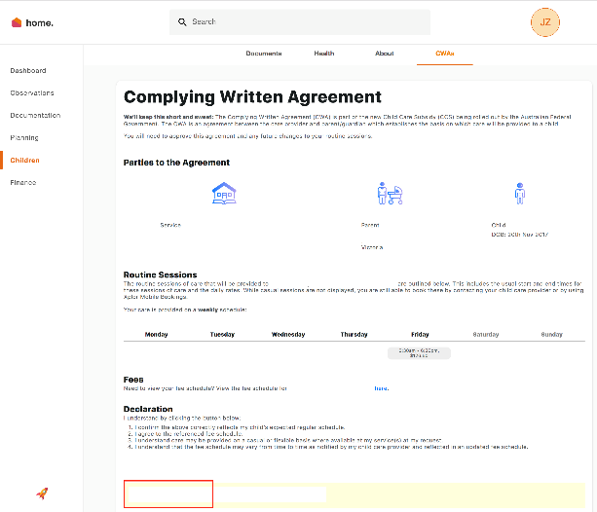
Troubleshooting:
- Firstly, please ensure you are using a computer, Google Chrome as a web browser and the primary carers account.
- If you are already doing the above, ask your centre admin to re-release your CWA.
- If you can still see nothing, please ask your centre admin to get in touch with Xplor support and we will troubleshoot the issue for you.

